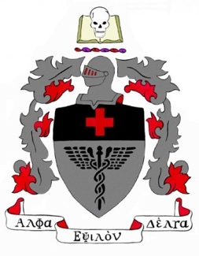
AED 44th Biennial Convention
Registration Form

March 17 - 19, 2022

Doubletree Hotel - Downtown Nashville
Nashville, Tennessee

ATTENDEE INFORMATION
First Name:  Address:  City:  Cell Phone:  University:  Emergency Contact Name: | Last Name:  Address (2):  State:  Email*(Required):  Chapter Name:  Emergency Contact Cell Number: | Zip Code:  Health Profession Interest:

REGISTRATION TYPE: Please check all appropriate boxes

AED National Member

Chapter Advisor

Honorary Member

Regional Director

Associate/Affiliate Member

Guest

REGISTRATION FEES: Credit Card & PayPal accepted

Early Registration National Member

$125 until 12/1/2021

Early Registration Non-Member

$150 until 12/1/2021

Pre-Registration National Member

$175 until 2/15/2022

Pre-Registration Non-Member

$200 until 2/15/2022

Please enter your National ID#

____________________________________

If you do not know your ID please email your
Full Name, University and Chapter Name to:

aed nationaloffices@tcu.edu

- Late Registration National Member Late Registration Non- Member
$200 after 2/15/2022 $225 after 2/15/2022

CHAPTER REPRESENTATION

- I would like to serve as my Chapter’s delegate
*eligible for travel award

I understand that I must be able to attend regional meeting, roll call, national business meeting and awards dinner.

- Suture Workshop Reservation (Space is limited, first 40 applicants will get in)
- I would like to serve on a committee:
(Optional)
*select committee to the right

I understand that I must arrive at convention in time for meetings starting at 4PM on Thursday, 3/17/2022.

Publications

Resolutions

Attendance

Activities
Special Dietary Needs:
Please check the appropriate box: Gluten-Free Vegan Only Peanut Allergies Fish & Shellfish allergies Other:___________________
Photography Notice:
As a participant in Alpha Epsilon Delta’s 44th Biennial Convention, I hereby grant permission to Alpha Epsilon Delta to use my photograph, taken during activities at this event on its national web page or in other official Society printed publications without further consideration. I acknowledge the Society’s right to crop or treat the photograph at will. I also acknowledge that the Society may or may not choose to use my photo at its own discretion.

Hotel link: **Use Promo Code “AED” to get the special room rate**
https://doubletree.hilton.com/en/dt/groups/personalized/B/BNADUDT-AED-20220317/index.jhtml?WT.mc_id=POG
PayPal: http://paypal.me/aednationaloffice

